Name : Modi Tejasv M

Subject : Python (task 3)

1. Write a python program to find whether the number is positive , negative or zero.

Ans:

var=float(input("Enter the number"))

if(var>0):

    print ("the number ",var," is positive")

elif(var==0):

    print("the number ",var," is zero")

else:

    print("the number ",var," is negative")

Output:

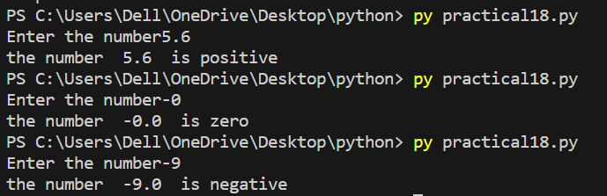

1. Write a python program to take input from the user split the amount into the rupee and paisa .

Ans:

var=input("enter the amount : ")

s=var.split(".")

if(len(s) >1):

    print("amount is ",s[0]," ruppes and ",s[1]," paisa")

else:

    print("amount is ",s[0]," ruppes and 00 paisa")

Output:

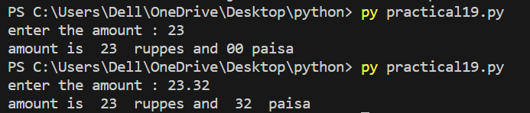

1. Write a python program to take input from user total number of seconds and convert them into hours and minutes.

Ans:

second=int(input("Enter the seconds "))

hours=0

minutes=second//60

second=second%60

while(minutes>59):

    hours=hours+1

    minutes=minutes-60

while(second>59):

    minutes=minutes+1

    second=second-60

print(hours," : ",minutes," : ",second )

Output:

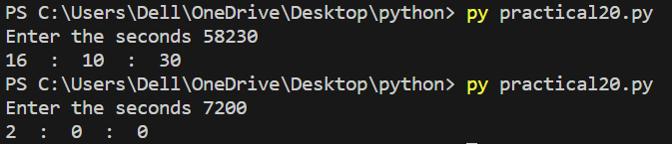

1. Write a python program to count the odd and even number between 1 to n.

Ans:

var=int(input("Enter the number "))

c=0

d=0

foriinrange(1,var):

    if(i%2==0):

        d=d+1

    else:

        c=c+1

print("the odd number in list is ",c)

print("the even number in list is ",d)

Output:

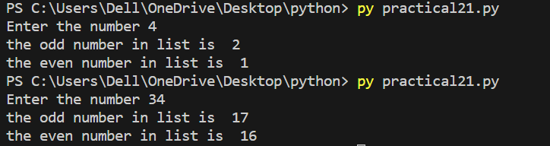

1. Write a python program to print all numbers which are divisable by 7 and also multiplication by 5 between 1500 to 2700.

Ans:

foriinrange(1500,2700):

    if(i%7==0andi%5==0):

        print("number is ",i)

Output:

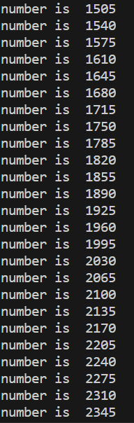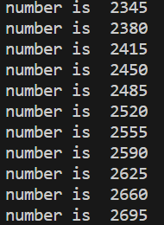

1. Write a Python program to guess a number between 1 to 10. User is prompted to enter a guess. If the user guesses wrong then the prompt appears again until the guess is correct, on successful guess, user will get a “Correct!!!!" message, and the program will exit.

Ans:

importrandom

var=int(input("Enter the number bettween 1 to 10 "))

r=random.randrange(1,11)

while(var!=r):

    var=int(input("not match enter another number "))

if(var==r):

    print("guess is right ")

Output:

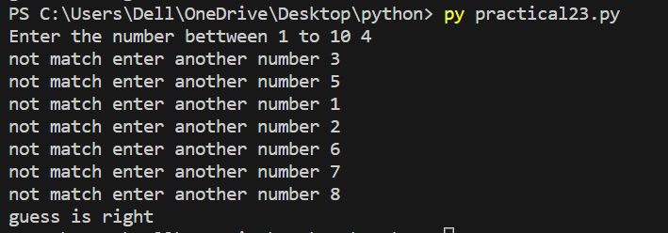

1. Write a python program to perform following operations on List and display the results after each operation:

(i)Create list with elements 57, 89, 78 and 1.

(ii)Insert 50 on third position and 25 on first position.

(iii)Delete second last element of the list.

(iv) Reverse the list

(v) Find maximum and minimum of the list

(vi) Sort the list

Ans:

list1=[57,89,78,1]

print(list1)

list1.insert(2,50)

list1.insert(0,25)

print(list1)

list1.pop(-2)

print(list1)

list1.reverse()

print(list1)

print("minimum of list1 is ",min(list1))

print("Maximum of list1 is ",max(list1))

list1.sort()

print("the sort of list1 is ",list1)

Output:

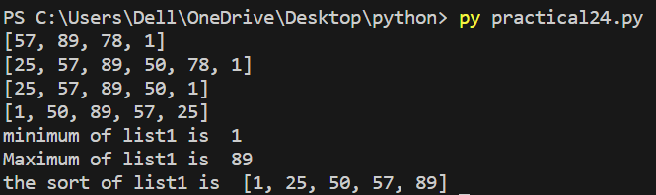

1. Write a Python program to to perform following operations on Tuple and display the results after each operation:
2. Create tuple with elements 65,12, 78 ,12, 23 and 7
3. Display 4th element from starting and 2nd element from last.
4. Count the occurence of 12 in the tuple
5. Create tuple containing all your subjects
6. Find minimum and maximum from both the tuples.

Ans:

t=(65,12,78,12,23,7)

print(t)

print("the 4th element in tuple is ",t[3], "and last 2nd element in tuple is ",t[-2])

print("count of 12 in tuple is ",t.count(12))

t1=("CCV","OOAD","DAA","PYTHON","NOSQL")

print(t1)

print("the max in tuple 1 is ",max(t)," also the max in tuple 2 is ",max(t1))

print("the min in tuple 1 is ",min(t)," also the min in tuple 2 is ",min(t1))

Output:

